**An Invitation to complete an anonymous electronic survey as part of a Monash University, Master of Wound Care research project**

**Project ID:** MUHREC project ID: **45572**

**Project title:** Acute hospital nurses Attitudes and Beliefs of wound care: a cross-sectional survey

**Aim:** As partof a master of wound care research project we invite all Australian Acute Hospital Nurses to share your perception of providing wound care in the acute hospital setting, to explore how you perceive the prioritisation, decision making, level of interest and confidence in wound care, and the facilitators and barriers to your provision of wound care.

**Voucher:** This survey should take 20 to 30 minutes of your time, and we have the possibility of receiving ten fifty-dollar vouchers, selected randomly, to thank participants for their input.

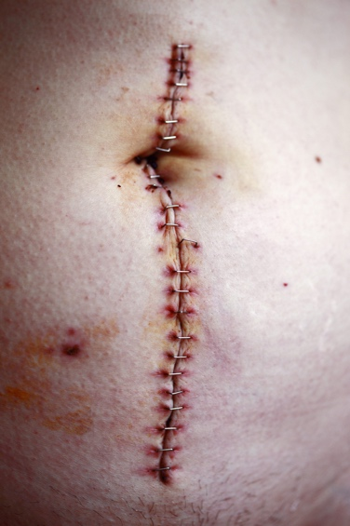**Inclusion criteria:**

We invite qualified registered nurses and enrolled nurses who are working in the Australian acute hospital setting to participate. Exclusion criteria include other health care professionals, and ENs and RNs working in community, aged care facilities and outpatients.

Please follow this link to view the **Explanatory statement**

For further information please contact Holly Ferguson via email: hfer0015@student.monash.edu

To access the survey please [follow this link](https://monash.az1.qualtrics.com/jfe/form/SV_3kstwCNlUyBbPmu) or scan the below QR code

